Assignment -7

Name- Harsh Kumar

Email – [hs150harsh@gmail.com](mailto:hs150harsh@gmail.com)

**🛠 Execute-MSI – Installation and Uninstallation**

**🔹 Installation**

**Execute-MSI -Action 'Install' -Path 'AppInstaller.msi' -Parameters 'REBOOT = ReallySuppress ALLUSERS=1 /qn'**

* **Purpose**: Installs MSI packages silently.
* **Common Parameters**:
  + /qn: Quiet mode, no UI.
  + REBOOT=ReallySuppress: Prevents reboot.
  + ALLUSERS=1: Installs for all users.
* **Best Practice**: Validate MSI with Orca or msiexec /l*v logging.

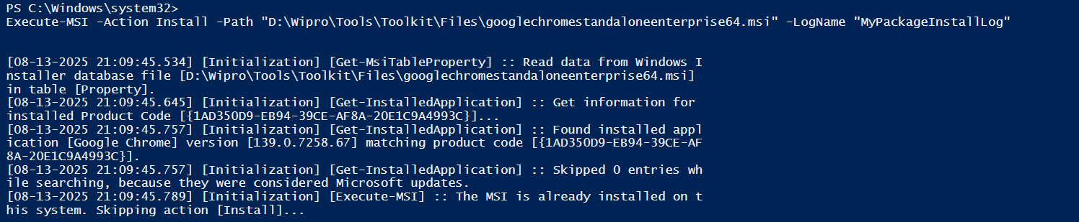

**🔹 Uninstallation**

**Execute-MSI -Action 'Uninstall' -Path '{ProductCode}' -Parameters '/qn'**

* **ProductCode**: GUID from registry (HKLM\Software\Microsoft\Windows\CurrentVersion\Uninstall).
* **Tip**: Use Get-WmiObject -Query "SELECT * FROM Win32_Product" to list installed MSI apps.

Not enough courage to delete something

**⚙️ Execute-Process**

**Execute-Process -Path 'setup.exe' -Parameters '/silent /norestart' -WindowStyle 'Hidden' -WaitForCompletion $true**

* **Purpose**: Runs EXE installers or custom scripts.
* **Key Flags**:
  + -WindowStyle 'Hidden': Suppresses UI.
  + -WaitForCompletion: Ensures process finishes before continuing.
  + -IgnoreExitCodes '1,3010': Avoids failure on soft reboots or warnings.
* **Use Case**: Deploying vendor EXEs like Chrome, Zoom, etc.

**🧩 Execute-MSP**

**Execute-MSP -Path 'patch.msp' -Parameters '/qn'**

* **Purpose**: Applies patch files to MSI-based apps.
* **Precondition**: Base MSI must be installed.
* **Tip**: Use msiexec /p patch.msp /qn manually to test before scripting.



**🛡 Install-MSUpdates**

**Install-MSUpdates -UpdatePath "$dirFiles\Updates" -IgnoreReboot**

* **Purpose**: Installs .msu or .cab updates.
* **Use Case**: Deploying cumulative updates or hotfixes.
* **Best Practice**: Test on VM snapshot before production rollout.

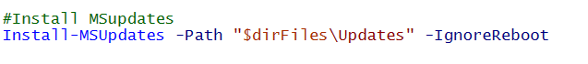

Older Version don’t work

**🧬 Create Active Setup**

**Register-ActiveSetup -StubExePath "$dirSupportFiles\MyStub.exe" -Key 'MyAppActiveSetup' -Version '1.0.0' -Arguments '/configure'**

* **Purpose**: Ensures user-level setup runs at login.
* **Registry Path**: HKLM\Software\Microsoft\Active Setup\Installed Components
* **Use Case**: Setting HKCU keys, user profile configs.
* **Tip**: Stub EXE can be a wrapper script or compiled PowerShell.



Same again older version doesn’t work

**📁 Copy/Delete/Move Files and Folders**

**📤 Copy**

**Copy-File -Path "$dirFiles\config.xml" -Destination "$envProgramFiles\App\Config" -Recurse**

**🗑 Delete**

**Remove-Folder -Path "$envProgramFiles\App\OldFiles" -ContinueOnError $true**

**🔀 Move**

**Move-File -Path "$dirFiles\log.txt" -Destination "$envProgramData\App\Logs"**

* **Best Practice**: Use Test-Path before file operations.
* **Error Handling**: Wrap in Try-Catch for logging failures.



Newer version can only run

**📦 Commands for Installation/Uninstallation**

**MSI**

**Start-Process 'msiexec.exe' -ArgumentList "/i App.msi /qn /norestart" -Wait**

**Start-Process 'msiexec.exe' -ArgumentList "/x {ProductCode} /qn /norestart" -Wait**

**EXE**

**Start-Process 'setup.exe' -ArgumentList "/silent /norestart" -Wait**

* **Use Case**: When toolkit commands aren’t flexible enough.
* **Logging Tip**: Add /l*v install.log for verbose logs.

**🧾 *Create/Delete/Modify Registries***

***🆕 Create***

* **New-RegistryKey -Key 'HKLM\Software\MyApp'**
* **Set-RegistryKey -Key 'HKLM\Software\MyApp' -Name 'Version' -Value '1.0.0' -Type 'String'**

**❌ *Delete***

**Remove-RegistryKey -Key 'HKCU\Software\OldApp'**

***✏️ Modify***

**Set-RegistryKey -Key 'HKLM\Software\MyApp' -Name 'InstallPath' -Value 'C:\Program Files\MyApp' -Type 'String'**

* **Best Practice**: Use Test-RegistryKey and Test-RegistryValue before changes.
* **Backup Tip**: Export keys before deletion using reg export.

The Consequencss can be dangerous so I avoided it

***🔄 Start/Stop Services***

**▶️ *Start***

**Start-Service -Name 'Spooler'**

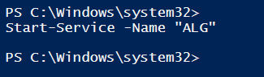

**⏹ *Stop***

**Stop-Service -Name 'Spooler' -Force**

* **Use Case**: Restarting services post-install (e.g., antivirus, print spooler).
* **Check Status**:

Get-Service -Name 'Spooler' | Select-Object Status

* **Best Practice**: Use Set-Service to configure startup type:

**Set-Service -Name 'Spooler' -StartupType Automatic**